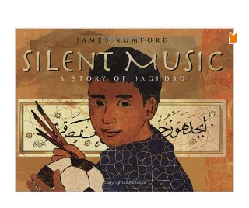**Silent Music: A Story of Bagdad**

By James Rumford

|  |  |  |  |
| --- | --- | --- | --- |
| motion | |  | |
| resists |  | |  |
| genius | | | |

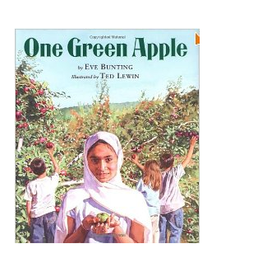**One Green Apple**

By Eve Bunting

jolt

fondly

grunt

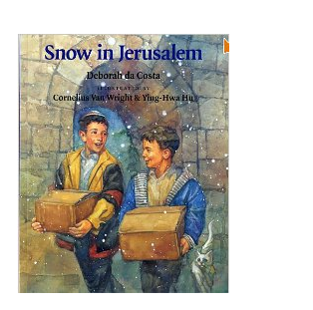**Snow in Jerusalem**

by Deborah da Costa

hastily

darted

rummaged



**I Am the Dog**

**I Am the Cat**

by Donald Hall

alert

vanished

disguised

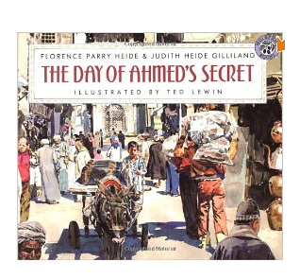**Day of Ahmed's Secret**

by Florence Parry Heide

tangled

mingle

caravans

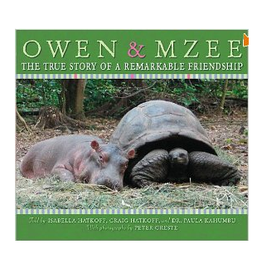**Owen & Mzee:**

**The True Story of a Remarkable Friendship**

by Isabella Hatkoff and

Craig Hatkoff

wallowed

commotion

inseparable